INVESTIGATING THE IMPACT OF LANDUSE AND LANDCOVER CHANGE ON FLOOD RELATED DAMAGES

Abstract

The usage of the land and the coverage variations are considering single source for changing of a crunch. In this work, we discovered the spatio-temporal LULC changes from 2000 to 2021 and their hazardous effects on balance of the water of on upper Jhelum River Basin. For this, purpose we should use the model Soil and Markov chain model for the investigation the negative effects evapotranspiration (ET) and on water yield. We see ET and water yield decrease and increase on basin in mm/ year. The conclusions of this work would be able to monitor the sustainable development of LULC and the management of water resources and watersheds. Arc map 10.8 and Google earth engine used for the determination of change in land use and land cover at upper Jhelum River Basin. At this level, urgent restoration, conservation of water and preservation of further changes in land use and land cover and related toward flood damages.
Keywords: Hydrology. Evapotranspiration LULC changes, Afforestation, water yield GEE, and remote sensing.

Introduction

Human practices have intensely altered in the surface of land on which we lived. Mostly, the management of usage of land and land coverage change alteration affects the hydrology of water bodies that adjusts the hazards of floods and natural resources for both the environment and human needs. In several places of the world, the extant and successive vulnerabilities with this threat have intensely increased over the last few centuries (Bectol et al., 2005). This style is changing due to anthropogenic activities, which are commonly relates in usage and land coverage change besides consequent losses now flood plain. General belief is that these extreme flood events are occurs because of changes in both climates and the land, use and land cover change (Reynard et al., 2001).
Table 1: Explanation of Land use and land cover changes
(LULC) TYPES | (LULC) Description
Vegetative area | The agricultural lands, forests, lands of vegetation, and Parks
Build-up area | Commercial, and inhabited buildings & systems of roads
Water bodies | Rivers, low-lying lands, canals, land of marshes and ponds
Bare soil | Open land surface, land not in use, empty fallow and bare soil

Remote sensing practices are collective with geographic information systems (GIS) used for the analysis of Landsat images for examination of temporal land coverage and land usage changes (Munsi et al., 2010). Remote sensing techniques are broadly use in land used and land cover studies with time and access arrangement of change Such methods usually measure quantity, but they are rather supplementing by qualitative techniques like conferences with locals living in this area. Remotely (Naha et al., 2021) sensed photographs are helpful for the detection of these changes that can be collect by using socio-spatial data achieved through anthropogenic techniques (McCracken et al., 1999).
Consequently, investigative the consequences and practices of altering land cover and land use are significant for ecologists, hydrologists, and the managers of land (Stonestorm et al., 2009) Towards examine the impression of land cover and terrestrial use change happening the hydrological cycle of a crisis spatially isolated hydrologically used reproductions remain active such as (HMS-HEC) VIC (Garg et al., 2017). Assessment of changes due to temperature, precipitation and the identification of most affected areas by the flood damages.
Estimate land use and land cover change and flood related damages in this zone and identification of those areas, which bear severe climate change due to change in land use and land cover change. Khan and Iqbal (2014) showed their research in the subdivision Azad Jammu and Kashmir for examines temporal and spatial use of land coverage changes from 1998 from 2009, and examine a reduction in bare vegetation, forests and increases in the settlement. (Kakembo & Development et al., 2003) investigated the LULC alteration from 1992 to 2017 in the Kashmir valley, which show an increase in both built-up areas and plantations although their decrease in agricultural land.
Ammar and Younis (2017) determined that overall alteration in discharge was insignificant. The effect of LULC alteration of resources on water has been assessing in different revisions at the local level.
In the UK, flood risk calculations (e.g., Hall et al., 2005) frequently implement the loss model existing in Penning-Rowsell et al. (2005), evaluating both direct and indirect financial damage. Expert-based damage functions are applied, which measure flood damage considering both flood duration and water depth. By openly taking into account possible flood damages, these risk calculations recognize people and effects at risk of flooding, which in turn is a origin for the purpose of flood assurance premiums (Grossi & Merz et al., 2010) and evaluation of the result and competence of flood qualification events (Koks et al., 2014; de Moel et al., 2014). As flood risk organization has constant to grow into a combined, system-wide method, flood mitigation methods are increasingly combining nature-based explanations (EEA, 2015; Sayers et al., 2015; SEPA, 2016). Such measures include the protection and establishment of natural ecosystems at calculated locations in catchments, since stagnated systems have the capability to affect the hydrology of small- to medium-sized catchments by improving water infiltration and preservation (Bronstert et al., 2002; Peel, 2009).
Conversely, the procedure of sticking soil surfaces for development, e.g., with solid surfaces, makes these surfaces waterproof and stops water infiltrating into the soil, thus declining the potential for water storage and aggregate the segment of rapid surface runoff collecting in downstream zones (Lin et al., 2007; Miller et al., 2014; Poelmans et al., 2011).
Consequently, land use systems have the ability to either exacerbate or mitigate flood damage and risk downstream. Based on this foundation, we existing a spatially explicit, assessment framework of qualified flood risk to evaluate land use changes as flood mitigation measures. This framework compares direct, tangible economic flood harms and the associated hazard before and after exact land use change situations, whereby the inventive land use works as a standard scenario. The methodological methods of the reasonable risk framework are first explained, after which a presentation of this framework is obtainable on a case study in the Maarkebeek basin in Flanders, Belgium.
Flood magnitudes in Flanders have been recorded in a geospatial flood documentation outlining the determined extent of flooded areas from 1988 to 2016 (Van Orshoven, 2001). The flood damage model constructed on the depth–damage cambers of LATIS, flood harms were assessed from some flood measures occurring in the Maarkebeek basin amongst 2000 and 2016, of which the amount is noted in the geospatial flood collection. The complete flood threat was determined by joining the flood harms of these procedures with their corresponding probability of incident.

Study Area
Jhelum River (Watershed Mangla Dam) is situated among 73-75.620E and 33⁰ N and it takes a whole area of drainage is about 33,39KM2. The topography characterized by mountains with an altitude that differs after 232 in the little land zone to 6284 m trendy the great land area. The catchment sanitations it is gracefully into the reservoir of Mangla, which is, consider the second greater basin of Pakistan.
The water in this basin is use for two determinations.
For the irrigation of practically 14.83 million Acers agricultural land and create 1000MW electricity which is 16% of the entire manufacture of electricity whole the hydel power plant.
The complete basin has mean yearly precipitation is almost 1195 mm and a mean yearly temperature is 13.1 ⁰ C. The increase in altitude reductions the temperature of the basin (beginning south- north) but the procedure of rainfall does not monitor a detailed tendency in like a challenging geography. In this region above 69%, of rain follows from the month of March to august. The continuing normal high temperature of the basin is extending from 48⁰ C in month of January (the coolest month) to 242⁰ C in the month of July (the warmest month). The JBR categorized through its higher heterogeneity of soil and land cover. The chief types of soil present in this basin such as Gleyic soil (47%), Mollic Planosols soil (23%), and Calaric Phaoeozems. The area of drainage this basin is diverse coverage of lands such as agriculture (28%), water (4%), forest (26%), sparse vegetation (36%), and settlement (1%).

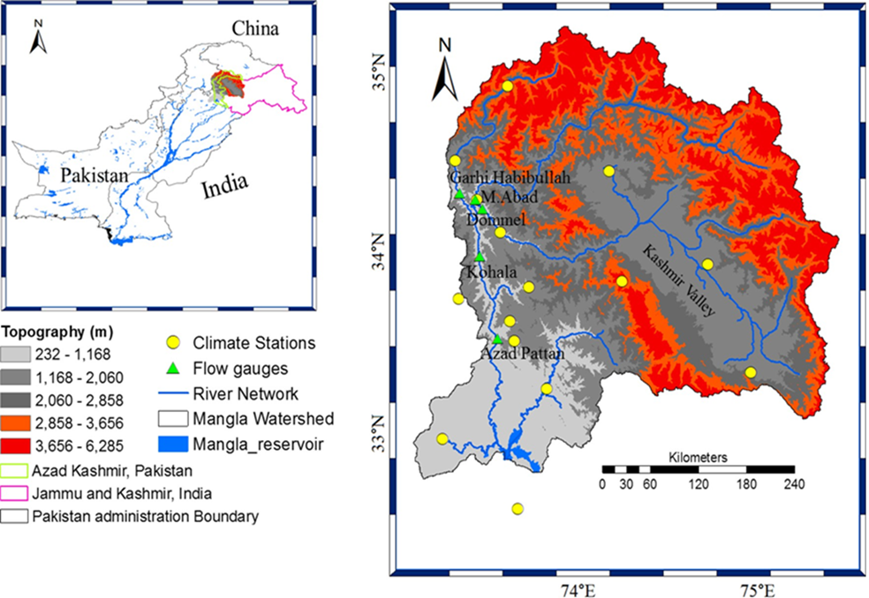
Figure1: Study area map
Table 2: Limitations of Landsat, and sensors used in this study.
S.no | Satellite/sensor | Spatially resolution | Spectrally resolution | Band use
 | Landsat 5 (TM) | 30m | Multispectral  (8 bands) | 1,2,3,4,5,7
 | Landsat7 (ETM) | 30m | Multispectral  (8 bands) | 1,2,3,4,5,7
 | Landsat8  (TRIS/OLI) | 30m | Multispectral  (11 bands) | 1,2,3,4,5,7, 9

Landsat

Pre-processing

Image processing

Supervised classification

LULC classification

Temperature and rainfall maps

NDVI maps

Accuracy
Assessment

Land surface temperature
LULC maps

Flood damage
Statistical analysis
Land use and land cover change

Relationship between LST and NDVI

2: Methodology flow chart

data ACQUISITION
For this research I need different types of data to find my objectives .As I take temperature data to find LST of the area then for the calculation of LULC I take different satellites images .Following data as follows.
Satellite Data
To assess the fluctuations in the use of land and the coverage (LULC) normalized difference vegetation index (NDVI) over a 21-year period (2000, 2007, 2014, and 2021) in the study area, remote sensing imagery data from Landsat 8 (OLI) and Landsat 7 (ETM+) satellites were developed. These imageries were obtained beginning the United States Geological Survey (USGS) website (http://www.earthexplorer.usgs.gov, accessed in 2020).

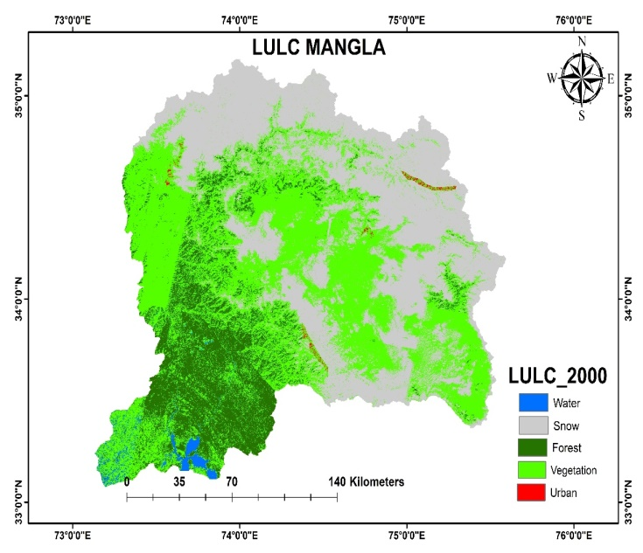

Table ‎4.1: Statistics of lulc 2000
Classes | Area in sq.km
Water bodies | 174.5069
Snow | 12.90446
Forest | 2288.047
Vegetation | 22476.89
Urban | 216.1609

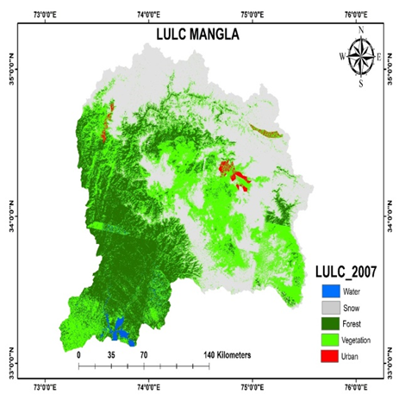
Table ‎4.2: Statistics of lulc 2007
Classes | Area in sq.km
Snow | 20.53607
Vegetation | 22417.44
Urban | 217.5928
Forest | 1935.313
Water bodies | 192.0258
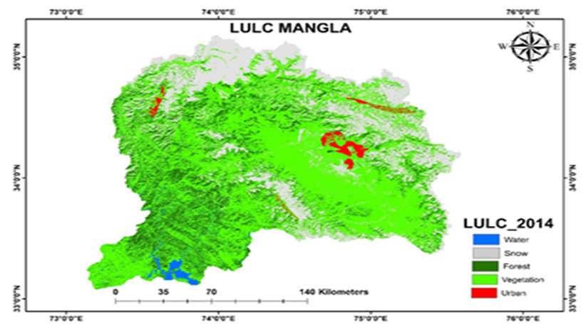
Table ‎4.3: Statistics of lulc 2014.
Classes | Area in sq.km
Snow | 37.6833
Vegetation | 22793.91
Urban | 227.1698
Forest | 2174.041
Water bodies | 269.0777
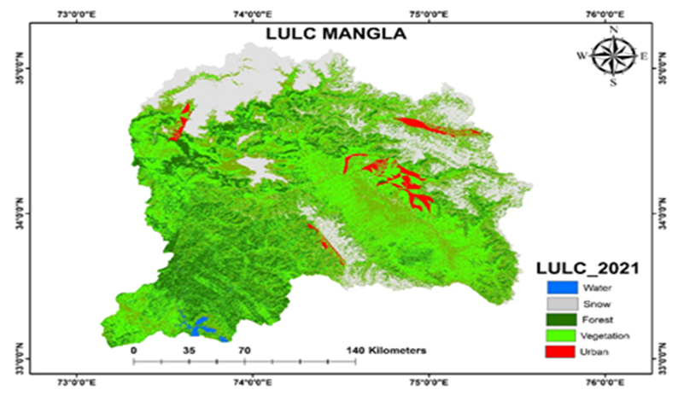

Table ‎4.4: Statistics of lulc 2021.
Classes | Area in sq.km
Snow | 42.57331
Vegetation | 23493.91
Urban | 232.9735
Forest | 2153.868
Water bodies | 288.5686
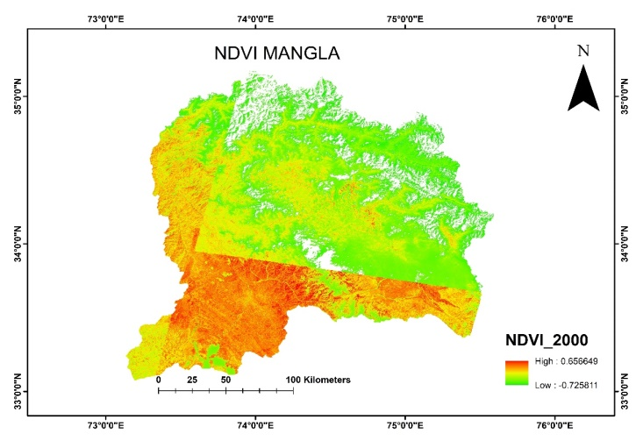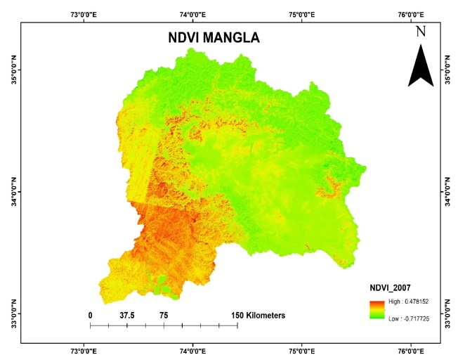

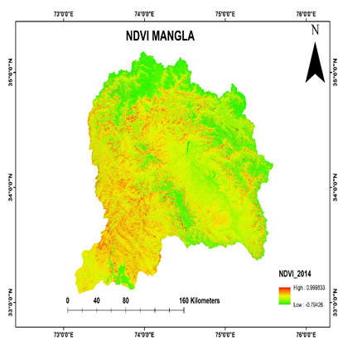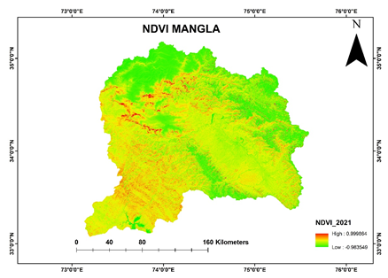

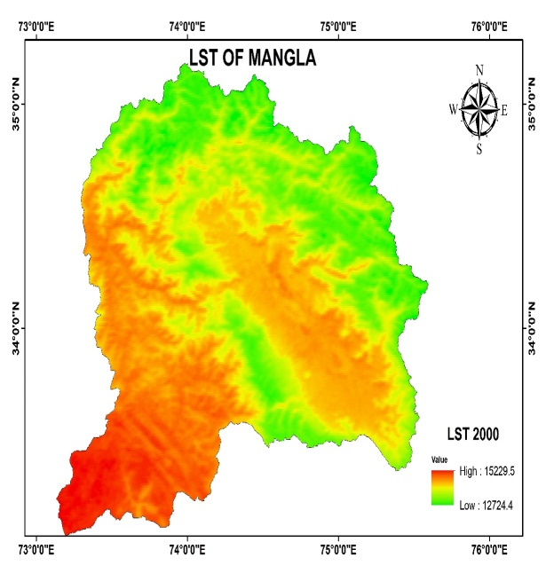
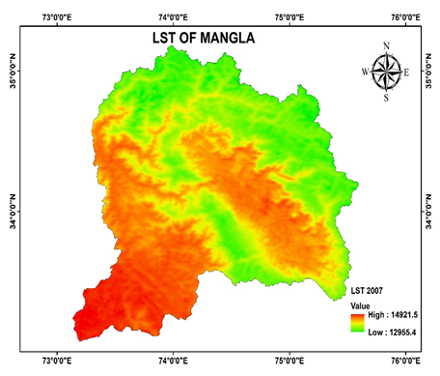

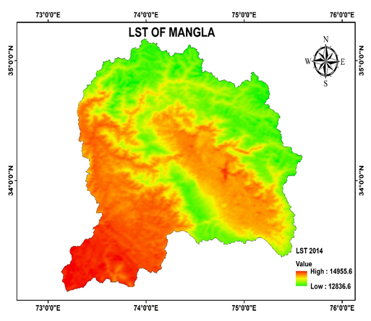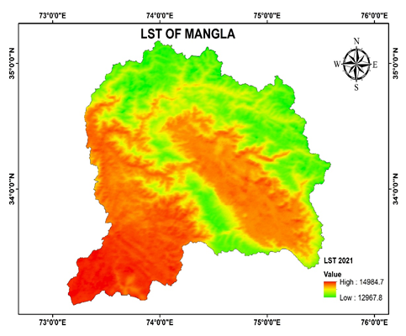

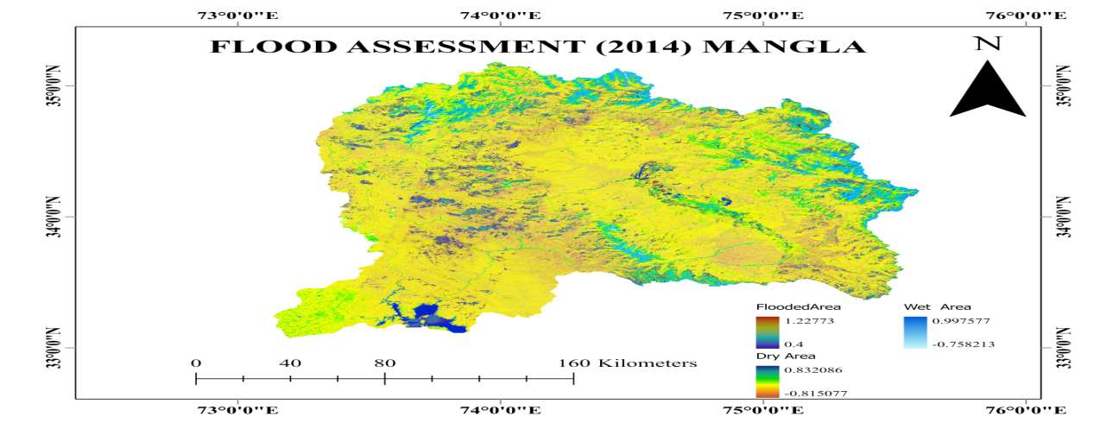

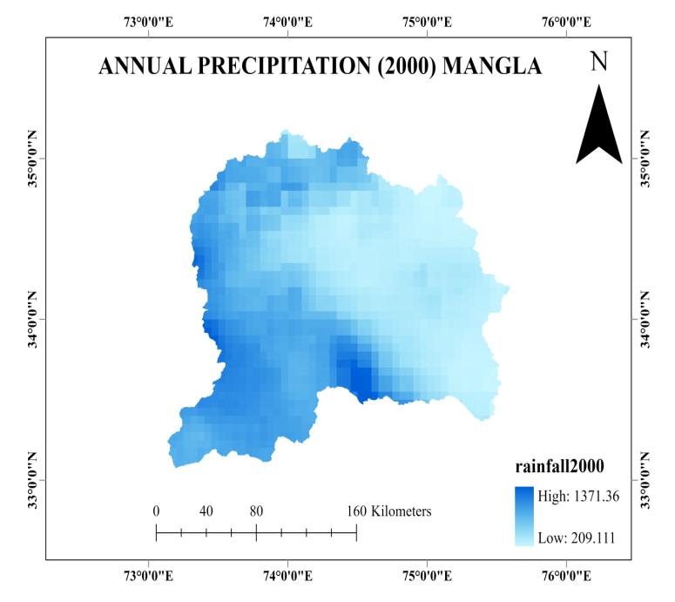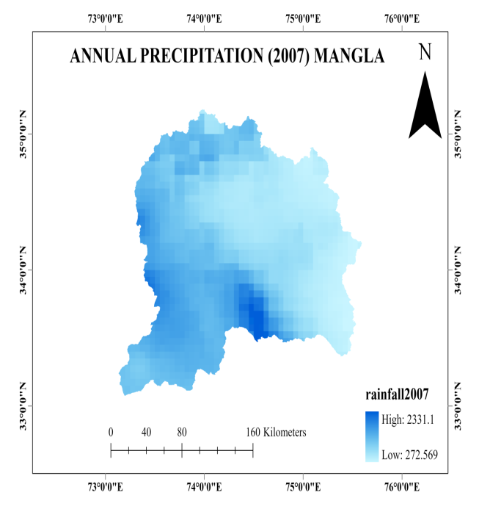

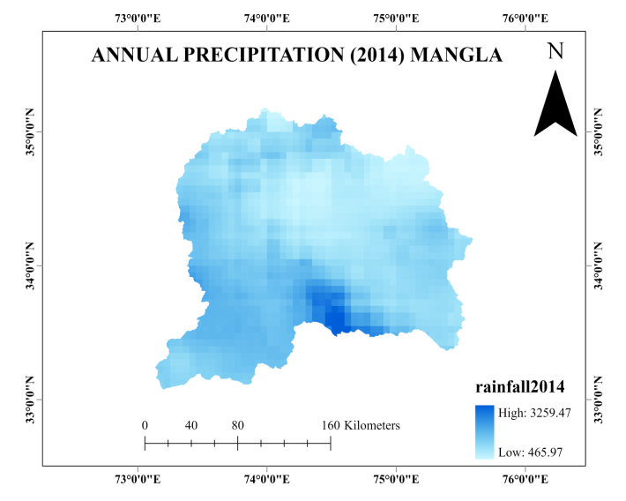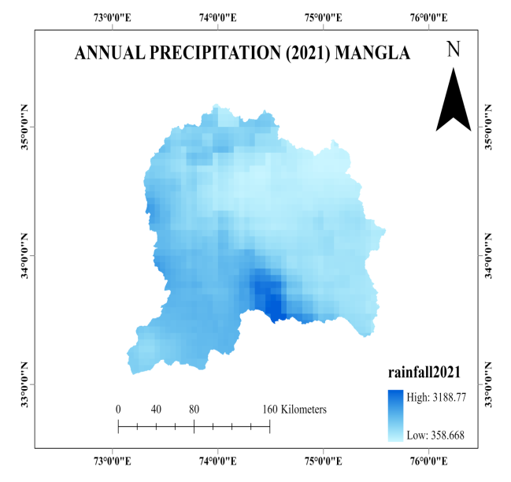

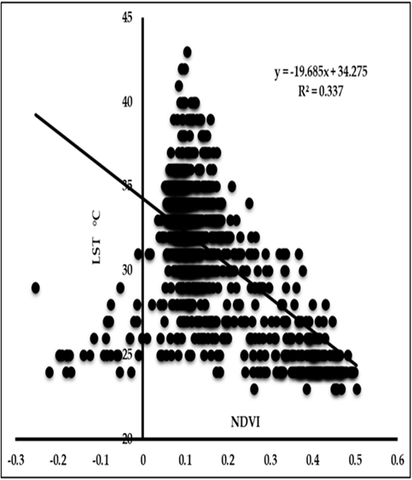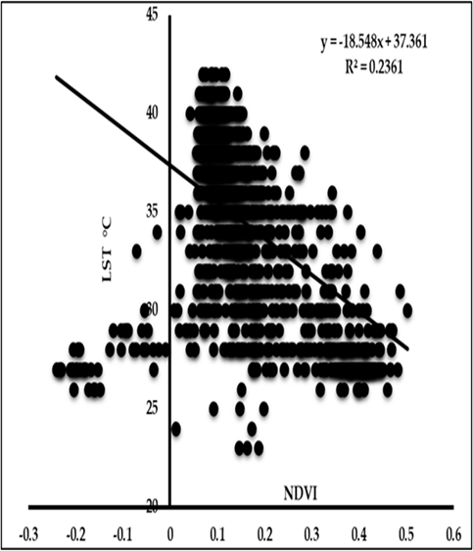
Figure: shows the correlationship between LST-NDVI 2000-2021.

DISCUSSION
The hydrology of a watershed can be meaningfully affected by fluctuations in use of land and the coverage of land making it a crucial factor to study. Thus, we conducted an investigation into the spatio-temporal changes in LULC between the years 2001 and 2018 within the Jhelum River Basin. Our aim was to understand the impacts of these changes on the flood damages of the region. One crucial aspect of LULC dynamics with significant consequences on the natural environment is the changing patterns and rates of land use changes, particularly in watershed fringes, where agriculture, forestry, and other land uses are prevalent. Additionally, the study estimated the average value of land surface temperature (LST) for the reading zone. LST values were derived from corrected Landsat imagery for the years 2000, 2007, 2014, and 2021. Additionally, this modification was more evident on the scales of sub-basin. Certain sub-basins, specifically in the northern portions of the study region, demonstrated intensification in WY outstanding to a growth in the areas of snow cover. Likewise, excesses land use situations also presented an important impact on the balance of the components of water.
In this research, we concentrated on appreciative how variations in the use and the coverage of land between 2000 and 2021 have influenced the hydrology of the Jhelum river sink. We utilized the tool use of soil and water to assess the influence of these the use and the coverage changes of land on flood damages and evapotranspiration. To ensure the accuracy of our findings, the model was validated and calibrated using expulsion data from before simulating different land use scenarios.
Throughout the study period, we observed an increase in forested areas, settlements, and water bodies. At the catchment scale, the introduction of afforestation resulted in a reduction of water yield and surface runoff while increasing evapotranspiration. These effects were even more significant at the sub-basin scale.
Overall, our research highlights the crucial role of LULC changes in shaping the hydrological dynamics of the Jhelum river basin. The increase in forest cover, settlements, and water bodies has had notable implications for water yield and evapotranspiration, emphasizing the importance of sustainable land management practices to maintain a balanced in the water and watershed.
Hydrological procedures, like as surface runoff, evapotranspiration (ET), and the flow of base, are influenced by numerous factors; comprising the use of land and the coverage of land (LULC) changes. According to Zhao et al., (2013) these trainings have highlighted the important impact of LULC changes proceeding hydrological processes. For instance found that alterations in the use of and coverage of land can require considerable properties on atmospheric conditions, such as temperature and precipitation.
In 2000 while we analyze the land use land cover change there is much more forest vegetation and snow cover in that area. A little bit urban area is showing through this analysis a non-significant alteration in a maximum and rainfall tendencies was noticed over the UJRB, however an important growth in minimum was distinguished. These atmospheric changes, in turn, act as key drivers in the hydrological cycle and consequently affect the water balance within a watershed. The water balance of a watershed is composed of factors such as stream flow, base flow, and evapotranspiration. Therefore, changes in the use of land and coverage of land container bring about modifications in these hydrological elements, ultimately impacting the overall water balance of the region. Now we talk about 2007 LULC analysis there is some depletion in forest cover in the study area while remaining are not much more change. In command to assess and calculate yearly spatial and temporal patterns and developments, the slope amongst other variables of climate and NDVI was calculated. Numerous research studies have been carried out in Kashmir and northerly Pakistan specifically in the upper Jhelum river basin, to examine land use and land cover (LULC) changes over time. Hassan et al. (2016) conducted a study focusing on the metropolis of Islamabad and that one atmosphere, revealing significant deforestation and urbanization between 1992 and 2012. Similarly, butt et al. (2015) investigated the simply watershed and observed an alarming increase in settlements coupled with a decline in vegetation cover. In 2014 analysis if we see difference between 2000 and 2014 analysis there is a big change in urban development and snow cover depletion which is due to rising the temperature or climate change effect in that study area. Climate change productions an important role in altering vegetation efficiency subtleties, which eventually distress the hydrological sequence of a division concluded evapotranspiration.
In foothills of the Himalayas Mountains in Pakistan, manna et al. (2019) found a noticeable increase in agricultural and built-up areas, while the forested regions experienced a decline. Turning attention to the sub-division of azad Jammu and Kashmir, Iqbal and khan (2014) explored spatial and temporal fluctuations in the use land and the coverage between 1998 and 2009. Their study uncovered a concerning reduction in forest and bare vegetation areas, along with a substantial expansion of settlements. To summarize, these studies collectively provide compelling evidence of various LULC changes in northern Pakistan and Kashmir over specific periods, pointing to issues such as deforestation, urbanization, decreased vegetation, and expansion of settlements.
To assess NDVI in the Mangla watershed, you would need satellite imagery with both red and near-infrared bands. The imagery can be acquired from various satellite platforms, such as Landsat, sentinel-2, or modis. To perform a comprehensive assessment, it is essential to have multiple NDVI images taken over different time periods. This will allow you to analyze changes in vegetation health and land cover dynamics over time. In 2000 the Forest and vegetation was in maximum condition where we can say that forest with the range of 0.5 to 0.9 , vegetation 0.2 to 0.5 ,snow cover 0 to 0.2 , water -0.3 to -0.1 and in last urban -0.4 to -0.9 in study area. Due to Landsat imagery there is some error in 2000 imagery. The assessment of NDVI in the Mangla watershed can provide valuable information for environmental monitoring, land management, and water resource planning. For a more accurate and up-to-date assessment, it's recommended to consult remote sensing experts or use specialized software and tools for NDVI analysis. In 2007 the Forest and vegetation was in maximum condition where we can say that forest with the range of 0.5 to 0.9 , vegetation 0.2 to 0.5 ,snow cover 0 to 0.2 , water -0.3 to -0.1 and in last urban -0.4 to -0.9 in study area. In 2007 higher maximum value is 0.478152 while lower value -0.7177 in Mangla watershed or Jhelum river basin.
NDVI is a widely used remote sensing index that provides an indication of vegetation health and density. It is calculated from satellite or aerial imagery and is based on the difference between the red light reflectance and near-infrared values. NDVI tenets collection from -1 to +1, where greater positive values typically represent dense and healthy vegetation, while lower or negative values indicate non-vegetated areas or areas with little vegetation. In 2014 the higher vegetation value is less than previous image which was in 2007 slowly u can say that vegetation.
Forest classes are decreases while urban area is increases here in the study area. For a current assessment of NDVI in the mangla watershed, you should consult recent satellite imagery or reports from environmental agencies or research organizations working in the region. Satellite data providers and research institutions often offer updated NDVI datasets and analyses for various regions globally. NDVI is just one of many remote sensing indices used for vegetation assessment. Integrating NDVI with other indices or data sources, such as land use/land cover maps or climate data, can provide a more comprehensive understanding of the Mangla watershed's ecosystem dynamics. In 2021 the Forest and vegetation was in maximum condition where we can say that forest with the range of 0.5 to 0.9 , vegetation 0.2 to 0.5 ,snow cover 0 to 0.2 , water -0.3 to -0.1 and in last urban -0.4 to -0.9 in study area.
In the past, climate patterns have typically been examined through trend analysis, focusing on individual locations one by one. Researchers would compare temperature and precipitation trends at one location with those at nearby sites, particularly when monitoring locations were widely spaced apart. However, when monitoring locations are concentrated in a local region, more advanced spatial analysis becomes feasible. By utilizing regional averages, it becomes possible to obtain a time series that better reflects large-scale climatic phenomena. Dealing with a single index series that represents spatially averaged data for a specific region simplifies the analysis process. The LST of Mangla watershed in 2000 average high value is 15229 PA while lower average value is12724 PA of the whole region. During the second data period, positive trends in annual temperatures were observed in both the entire catchment and its sub-catchments, with the exception of the mangla catchment. It depicts the time sequence of yearly temperatures for mangla sub-basins and its catchment. The findings indicate that climate change is manifesting more severely in the lower part of mangla catchment, where warming trends were evident, while the higher part of the catchment experienced cooling trends. When we see the average high temperature of 2007 which is 14921.5 while lower value is 12955 so we can see some positive changes in these seven years in the LST. The Mangla catchment area shows a notable increase in mean annual temperature at a degree of 0.14°c each decade, aligning well with the findings of Afzal et al, (2009). Afzal's study reported a rise in Pakistan’s mean temperature at a degree of 0.06°c each decade, based on an analysis of data from the previous century. Additionally, similar to fowler and archer's (2007) observations, the upper sub-catchments have experienced a decrease in minimum temperatures over the entire data period. As we can see the average high value of LST in 2014 is more than previous 7 years analysis which is14955 while lower average value is 12836 it means that in this region the LST is changing gradually year by year. This is the analysis of a 14-year dataset spanning from 2000 to 2014. Their findings revealed a notable warming trend in the maximum temperatures during the winter, spring, and autumn seasons across the upper, medium, and lower regions of the upper Indus basin (UIB). However, interestingly, the mangla catchment showed a cooling trend in the regions of upper area and a warming trend in the regions of lower area during the period of 2000 to 2014. Looking specifically at the last two decades (1991-2010), the researchers observed warming trends throughout the entire region, except for a minor lower part of kanshi, where no significant warming was detected for all these seasons. Furthermore, when analyzing the maximum, minimum, and mean temperatures for the summer season, the study found a decrease in temperature across all basins, supporting the previous results of khattak et al., (2011). As we see that in 2021 threw average high temperature or LST of this region is 14984 which is little higher than the previous 7 year analysis which I already calculated in this chapter while lower value is 12967 in this region. Floods are considered amongst the major frequent and destructive type of disasters, causing significant damage and disrupting livelihoods throughout the world. There is a wide range of flood risk management methods available that can reduce this destruction, and managing flood risks requires the estimation of flood hazards and the impacts that they can cause. The specific role of flood hazard assessment is to understand the probability that a flood of a particular intensity will occur over an extended period of time. The most recent floods of 2010 and past floods of 1992 and 1997 have been focused in this assessment the results were analyzed and the possible extend of flooding at downstream locations was estimated. In extreme flood of 1992 flood scenario about 13050m to 69204m were found vulnerable.
The mangla region map in the figure with a recorded value of 638mm provides a significant dataset that sheds light on precipitation patterns in the area. Precipitation is known as the fundamental component of the regional climatic system and it plays a vital role in determining several environmental processes and ecosystem dynamics. 2000 imagery shows a negative correlation between NDVI & LST. This means that the higher the NDVI, the lower the LST and vice versa. Similarly, 2021 imagery (Figure. 5) also depicted that the NDVI and LST have a linear and negative correlation. The correlation values between LST and NDVI in both imageries are 2000R²=0.337 and 2021R²=0.2361. The correlation gives a clear indication there was a linear and strong negative correlation. Hence, less vegetative areas experienced as high LST, and full greenery areas, agricultural land, water body have higher values of NDVI. The negative relationship between NDVI and LST was observed for all LULC categories. This study also delivers a recent outlook for correlation between NDVI & LST over the district that took place from 2013-2020.The NDVI range is -0.29 to 0.60 in 2000 and -0.26 to 0.54 in 2021. The lowest values refer to the sub-urban, mountain, and barren land of Mangla. In contrast, the highest values refer to the vegetation cover, agricultural land where the vegetation and greenery are the thickest. LST of Mangla from 2000-2021 indicates the highest temperature exists at the mountain, barren land, and settlements areas. The correlation between LST and NDVI and regression coefficient from NDVI to LST are negative, which means that where NDVI is lower has higher LST and where NDVI is higher has lower LST.

Conclusion
The research work demonstrates that the study area has experienced many LULC changes on flood related damages from 2000-2021 over the Mangla region. Five classes were made to detect LULC change by using supervised classification technique. However the results of this work showed a decrease in forest cover between 2000 and 2007 and while the period between 2014 and 2021 witnessed as decrease in class while and water bodies’ increases that is main reason of flood in this area. The low vegetation cover has reduced significantly where as an increase in built up and bare soil has been observed. Low vegetation reduced 22476.89km² to 23493.91km² from 2000 to 2021 respectively. This trend shows growth in population size, increase in deforestation, extension in road networks, uncontrolled grazing all these factors are responsible of LULC changes.
The second part of the study focus on the assessment of flood and precipitation analysis by using different factors like LULC, LST and NDVI all are used for the preparation of maps. Theses maps showed that change in LULC and the precipitation of the area the area under very risk comprises 8% than the area under higher risk category (45%) the area under medium category contribute 38% where as 16% and 0.85% is recognized as moderated and low risk category. The land-use changes relate the major drivers for increasing the local environment and LST. Different factor of increasing LST is barren land and mountains due to clearance of vegetation and land use activities related to development of infrastructure and topographic elements such as, height, slope and elevation. Moreover, temperature of surface is continuously expanding day by day, although the vegetation catalogue peak is relatively noticeable, particularly in water body areas and agricultural land. LST highly disturbs vegetation cover due to changes in climatic patterns.

LITERATURE CITED
Amir, S., Saqib, Z., Khan, A., Khan, M. I., Khan, M. A., & Majid, A. (2019). Land cover mapping and crop phenology of Potohar Region, Punjab, Pakistan. Pakistan Journal of Agricultural Sciences,56(1), 187–196. https://doi.org/10.21162/PAKJAS/19.7663.
Anwar, M. M., Rahman, A. U., & Aziz, A. (2020). Land-Use/Land-Cover Changes From 1990 To 2016 on the Territory of Mandi Bahauddin City (Punjab, Pakistan). Bulletin of the Moscow State Regional University (Geographical Environment and Living Systems), (3), 60–69. https://doi.org/10.18384/2712-7621-2020-3-60-69.
Bera, S., & Das Chatterjee, N. (2019). Mapping and monitoring of land use dynamics with their change hotspot in North 24-Parganas district, India: a geospatial- and statistical-based approach. Modeling Earth Systems and Environment, 5(4), 1529–1551. https://doi.org/10.1007/s40808-019-00601-2.
Hussain, S., Mubeen, M., Akram, W., Ahmad, A., Habib-ur-Rahman, M., Ghaffar, A., … Nasim, W. (2020). Study of land cover/land use changes using RS and GIS: a case study of Multan district, Pakistan. Environmental Monitoring and Assessment, 192(1). https://doi.org/10.1007/s10661-019-7959-1.
Majeed, M., Tariq, A., Anwar, M. M., Khan, A. M., Arshad, F., Mumtaz, F., … Shaukat, S. (2021). Monitoring of land use–Land cover change and potential causal factors of climate change in Jhelum district, Punjab, Pakistan, through GIS and multi-temporal satellite data. Land, 10(10). https://doi.org/10.3390/land10101026.

hirazi, S. A. (2012). Temporal Analysis of Land Use and Land Cover Changes in Lahore-Pakistan.Pu.Edu.Pk,13(1),188.Retrievedfrom http://pu.edu.pk/images/journal/studies/PDF-FILES/5 - Shirazi Geography Artical-7_v13No1.pdf.
Tariq, A., Shu, H., Siddiqui, S., Imran, M., & Farhan, M. (2021). Monitoring land use and land cover changes using geospatial techniques, a case study of Fateh Jang, Attock, Pakistan. Geography, Environment, Sustainability, 14(1), 41–52. https://doi.org/10.24057/2071-9388-2020-117.
urban expansion to 2030 and direct impacts on biodiversity and carbon pools. Proceedings
Rashed, T., & Weeks, J. R. (2003). Assessing the spatial and temporal patterns of urban growth and land use change in Dhaka, Bangladesh. Journal of Urban Planning and Development, 129(4), 95-113.
Bhatta, B., Saraswati, S., & Bandyopadhyay, D. (2010). Urban sprawl measurement from remote sensing data. Applied Geography, 30(4), 731-740.
Lambin, E. F., Geist, H. J., & Lepers, E. (2003). Dynamics of land-use and land-cover change in tropical regions. Annual Review of Environment and Resources, 28(1), 205-241.
Turner II, B. L., Lambin, E. F., & Reenberg, A. (2007). The emergence of land change science for global environmental change and sustainability. Proceedings of the National Academy of Sciences, 104(52), 20666-20671.
Wu, J. (2013). Landscape sustainability science: ecosystem services and human well-being in changing landscapes. Landscape Ecology, 28(6), 999-1023.

